Timescale dependence of environmental controls on methane efflux in Poyang Lake, China
Lixiang Liu¹, Ming Xu^{1,2*}, Renqiang Li¹, Rui Shao^{1, 3}
¹Key Laboratory of Ecosystem Network Observation and Modeling, Institute of Geographic Sciences and Natural Resources Research, Chinese Academy of Sciences, Beijing 100101, China
²Center for Remote Sensing and Spatial Analysis, Department of Ecology, Evolution and Natural Resources, Rutgers University, New Brunswick, NJ 08901, USA
³University of Chinese Academy of Sciences, Beijing 100049, China

Correspondence to: Ming Xu (mingxu@ igsnrr.ac.cn)

Abstract
Lakes are an important natural source of CH₄ to the atmosphere. However, the multi-seasonal CH₄ efflux in lakes has been rarely studied. In this study, the CH₄ efflux in Poyang Lake, the largest freshwater lake in China, was measured monthly over a 4-year period by using the floating chamber technique. The mean annual CH₄ efflux throughout the 4 years was 0.54 mmol m⁻² day⁻¹, ranging from 0.47 to 0.60 mmol m⁻² day⁻¹. The CH₄ efflux had a high seasonal variation with an average summer (June to August) efflux of 1.34 mmol m⁻² day⁻¹ and winter (December to February) efflux of merely 0.18 mmol m⁻² day⁻¹. The efflux showed no apparent diel pattern, although most of the peak effluxes appeared in the late morning, from 10:00 h to 12:00 h. Multivariate stepwise regression on a seasonal scale showed that environmental factors, such as sediment temperature, sediment total nitrogen content, dissolved oxygen, and total phosphorus content in the water, mainly regulated the CH₄ efflux. However, the CH₄ efflux only showed a strong positive linear correlation with wind speed within a day on a bihourly scale in the multivariate regression analyses but almost no correlation with wind speed on diurnal and seasonal scales.
Keywords: Methane, Sediment temperature, Temperature sensitivity, Substrate availability, Wind speed

- Introduction
Methane (CH₄) contributes to about 20% of global warming in terms of radiative forcing, and its concentration in the atmosphere increased at a rate of 0.5 ppb year⁻¹ in 1999–2006; this rate rapidly increased to 6 ppb year^{–1} from 2007 to 2011 (IPCC, 2013). Although the total global lake area accounts for approximately 3.7% of the Earth’s nonglaciated land area (Verpoorter et al., 2014), CH₄ emissions from global lakes account for up to 14.9% of natural CH₄ emissions (IPCC, 2013). However, this estimate has been associated with large uncertainties because of the high spatial and temporal variations of CH₄ emissions and the insufficient multi-seasonal measurements of CH₄ effluxes, especially in tropical and subtropical lakes (Yang et al., 2011; Ortiz–Llorente and Alvarez–Cobelas, 2012; Bastviken et al., 2015; Li and Bush, 2015).
CH₄ effluxes in lakes feature high temporal variations (Käki, 2001; Xing et al., 2004; Duan et al., 2005; Xing et al., 2005, 2006; Palma–Silva et al., 2013). For example, previous studies found that the mean CH₄ effluxes over a day were 0.018 and 68.27 mmol m⁻² day⁻¹, respectively (Xing et al., 2004; Duan et al., 2005; Chen et al., 2007; Podgrajsek et al., 2014a); even larger variations were found on a seasonal scale (Xing et al., 2005, 2006; Duan et al., 2005; Ortiz–Llorente and Alvarez–Cobelas, 2012; Wik et al., 2014). These large variations in CH₄ effluxes highlight the importance of frequent and multi-seasonal measurements (Bastviken et al., 2008; Chen et al., 2013; Bastviken et al., 2015). Unfortunately, most earlier studies on CH₄ emissions were based on short-term measurements, ranging from daily to seasonal scales, and were conducted during the day time (Xing et al., 2004; Duan et al., 2005; Xing et al., 2005; Schrier–Uijl et al., 2011; Rõõm et al., 2014). To our knowledge, multi-seasonal measurements of CH₄ effluxes have only been conducted in high-latitude lakes (Utsumi et al., 1998a, b; Huttunen et al., 2003; Rõõm et al., 2014; Wik et al., 2014), and few studies on tropical and subtropical lakes (Xing et al., 2005, 2006; Ortiz–Llorente and Alvarez–Cobelas, 2012), especially large ones, had measurement durations longer than one year.
The magnitude of CH₄ emission mainly depends on the dynamic balance between the microbial processes of CH₄ production, oxidation, physical transportation from the anaerobic zone to the atmosphere in lakes, and regulation by multiple, interconnected physical, chemical, and biological variables (Sun et al., 2012; Liu et al., 2013; Serrano–Silva et al., 2014; Rasilo et al., 2015). CH₄ production and oxidation are microbial processes regulated by organic carbon loading, dissolved organic matter, lake nutrient status, and N availability (Bridgham et al., 2013; Liu et al., 2013; Hershey et al., 2014; Rasilo et al., 2015); temperature (Liikanen et al., 2003; Marotta et al., 2014; Yvon–Durocher et al., 2014); lake depth and size (Juutinen et al., 2009; Rasilo et al., 2015); pH, O₂, NO₃²⁻, Fe³⁺, and SO₄²⁻ in the sediment and water column (van Bodegom and Scholten 2001; Schrier–Uijl et al., 2011; Bridgham et al., 2013); and populations and potential activities of methanogens and methanotrophs (Segers, 1998; van Bodegom and Scholten, 2001; Liu et al., 2015, 2016). CH₄ transportation is driven by three major mechanisms, namely, molecular diffusion, bubble ebullition, and plant-mediated transportation (Bridgham et al., 2013; Chen et al., 2013; Zhu et al., 2016). These mechanisms are affected by water stratiﬁcation and seasonal overturns of the water mass, which are determined by temperature (Palma–Silva et al., 2013; Rõõm et al., 2014), wind-forced mixing (Wanninkhof, 1992; Palma–Silva et al., 2013), water depth (Liu et al., 2013), boundary layer dynamics (Poindexter et al., 2015; Anthony and Macintyre, 2016), hydrostatic pressure (Chanton et al., 1989), and different vascular plants (Juutinen et al., 2009; Zhu et al., 2016). Most studies examined CH₄ emissions and their influencing factors in small lakes because of their large contribution to the global CH₄ budget (Bastviken et al., 2004; Downing et al., 2010; Bartosiewics et al., 2015; Holgerson et al., 2016). Although small lakes are a large source of atmospheric CH₄, CH₄ emissions from large lakes was not neglected due to their large areas (Bastviken et al., 2010; Rasilo et al., 2015; Townsend-Small et al., 2016). However, few studies reported temporal CH₄ emissions and their key regulating factors at different temporal scales in large lakes. Therefore, investigating the impacts of physical and biological factors on temporal CH₄ effluxes based on multi-seasonal measurements in a large lake is also important to estimate lake CH₄ emissions.
Poyang Lake, a subtropical lake, is the largest freshwater lake in China, but its multi-seasonal CH₄ emissions have not been adequately measured. In our previous study, we have explored the spatial variations of CH₄ efflux over the lake with 44 sampling locations (Liu et al., 2013). In addition, we also found that microbial biomass and community structure highly influenced CH₄ efflux in Poyang Lake (Liu et al., 2016). In this study, we measured the CH₄ efflux in three sites which we chose on the basis of our previous result over the course of 4 years in Poyang Lake to (1) examine the multi-seasonal mean CH₄ efflux; (2) explore the CH₄ efflux dynamics, including diel and seasonal variations; and (3) quantify the relationships between the CH₄ efflux and environmental factors, and identify the possible factors driving CH₄ effluxes at different temporal scales.

- Materials and methods
2.1. Site description
Poyang Lake (28°22′–29°45′N, 115°47′–116°45′E) is located in Southern China in Jiangxi Province, with a surface area of 3283 km² and a total catchment area of 162,000 km², which is separated to the northern and southern parts by the Songmen Mountain. Poyang Lake receives water input from five main tributaries, namely, the Raohe River, Xinjiang River, Fuhe River, Ganjiang River, and Xiushui River. The climate is humid subtropical with a mean annual temperature of 17.5 °C and an annual precipitation of 1680 mm (Ye et al., 2011). Vegetation in the lake is composed of macrophytes, including Carex sp. (Carex cinerascens Kükenth and Carexargyi Levl.etVant) and Artemisia selengensis in the hydrophyte zone, and the main submerged aquatic macrophytes, including Ceratophyllum demersum, Potamogeton malaianus, Potamogeton crispus, and Hydrilla verticillata (Wang et al., 2011).
This study was conducted near the Poyang Lake Laboratory of the Wetland Ecosystem Research Station (operated by the Chinese Academy of Sciences), which is located in the northern sub-basin of Poyang Lake in Xingzi County, Jiangxi Province (Fig. 1). The five tributaries flow into the lake in the southeast of Xingzi County, which then joins with the Yangtze River. The water level fluctuated dramatically from 7.78 m to 18.57 m above sea level (Wu Song) between the wet (April to September) and dry seasons (October to March) during the study period because of rainfall and Three Gorge management. Poyang Lake is not stratified (Zhu and Zhang, 1997), with mean and maximum depths of 8 and 23 m, respectively. The mean concentrations of total nitrogen (TN), total phosphorous (TP), suspended solids (SS), and chlorophyll a (Chl a) in Poyang lake were 3.45, 0.11, 39.98, and 9.04 mg L⁻¹, respectively (Yao et al., 2015).
2.2. CH₄ efflux measurements
The CH₄ efflux was measured using floating chambers, including both ebullition and diffusive fluxes (Bastviken et al., 2004, 2010). The floating chamber was fabricated using a PVC pipe 100 cm in length and 20 cm in diameter with Styrofoam floats attached to the sides. The floating chambers were inserted 80 cm into the water and 20 cm above the water surface to minimize the perturbation of the surface water flow to the pressure inside the chambers. We tested the chamber system with different insertion depths in the laboratory and field, and found that the current depth of about 80 cm could effectively prevent the impacts of the surrounding Styrofoam floats while maintaining the chamber balance in moderate winds. A similar design of floating chambers was used in previous studies (Lorke et al., 2015; Zhao et al., 2015). Earlier studies found that floating chambers should be seated at the water surface in a flowing-water system to minimize the “drag” effect of flowing water on chamber pressure (Bastviken et al., 2010; Vachon et al., 2013; McGinnis et al., 2015). However, the water in Poyang Lake did not have an apparent directional flow except for some waves during the measurement period. So the insertion depth was deeper than those of previous studies to avoid the impact of waves in Poyang Lake on the chamber body in the current study. A detailed description of the floating chamber system can be found in Liu et al. (2013). So we measured the total CH₄ efflux including both ebullition and diffusive effluxes and cannot differentiate ebullitive and diffusive fluxes by our chamber.
We collected a gas sample (ambient concentration) immediately after the chamber was closed and three other samples at a 20 min interval for 1 h. The gas was extracted into a 12 mL evacuated glass vial by a 2 mL syringe needle with an air pump, which enhanced the pressure in the vial to 3 bars. Subsequently, the gas samples were transported immediately to a laboratory for CH₄ concentration analysis. The CH₄ concentration was measured using a gas chromatograph equipped with a flame ionization detector (GC7890A, Agilent Technologies, Inc., Santa Clara, CA, USA). We used nitrogen (N₂) as the carrier gas, which ran at a flow rate of 30 mL min⁻¹. We calibrated the gas chromatograph for every four samples with a calibration gas of 2.03 ppm at 99.92% precision (China National Research Center for Certified Reference Materials, China). The oven and detector temperatures of the GC were set to 55 °C and 250 °C, respectively.
Calculation of the CH₄ efflux was based on the CH₄ concentration of the four samples using a linear regression model, which was calculated on the basis of the slope of the concentration change during the whole period when the chamber was closed. Data quality control was conducted following the method of Rasilo et al. (2015) before the regression models were fitted. As a result, most of the models performed satisfactorily, with a coefficient of determination (R²) greater than 0.95. In case of ebullition, the CH₄ concentration inside the chamber would deviate from the normal trend. Most of the CH₄ concentrations measured immediately after the ebullition point slightly decreased mainly because of the CH₄ diffusion back to water when the CH₄ concentration inside the chamber space increased suddenly from bubbling. To include the ebullition-induced CH₄ emissions, we only used two measured concentrations, the first measurement (ambient concentration) and an ebullition-adjusted concentration that was obtained by adding the diffusion-induced concentration increment when ebullition occurred (Fig. 2). Specifically, when ebullition occurred during the first 20 min, we obtained the ebullition-adjusted concentration by summing up concentration on 20 min and the 2-fold incremental concentration which was from concentration between the third and fourth sampling times. When the ebullition occurred at the third sampling, we summed up the concentration at 40 min and the incremental concentration between the first and second sampling times. When the ebullition occurred at the fourth sampling, we used the first and fourth sampling concentrations directly to calculate the slope of the total efflux.
Samplings took place at a monthly interval from January 2011 to December 2014 at three sites in Poyang Lake (Fig. 1): site A (Luoxingdun: 29°3′29′′N, 116°16′49′′E), site B (Mantianxing: 29°34′25′′N, 116°13′29′′E), and site C (Huoyanshan: 29°39′0′′N, 116°16′11′′E). The mean water depth in our sampling sites was 3 m. The sampling sites lacked aquatic plants. Our previous study examined the spatial pattern of the CH₄ efflux in the lake (Liu et al., 2013). Therefore, we focused on the multi-seasonal dynamics of CH₄ efflux in the current study. At each site, four chambers were placed approximately 10 m away from a small boat to minimize disturbance. Measurements were conducted from early morning to late afternoon with about 6 cycles of measurements for each chamber, except for days when the diel-cycle measurements were taken. We conducted four 24 h measurements at the three sites in 24–25 July 2011, 5-6 September 2012, 13–14 January 2013, and 14–15 January 2015 to examine the diel variations of CH₄ effluxes. These measurements were conducted every 2 h from 8:00 am to 8:00 am the next day, providing 12 cycles of measurements for each chamber per 24 h.
2.3. Environmental variables
Various environmental variables were also measured in the lake sediment, surface water, and atmosphere at each individual site and then averaged when we used. We collected surface water and sediment samples (0–15 cm) using a plexiglass water grab and a stainless steel sediment sampler (3 cm in diameter) after obtaining gas samples. The water and sediment samples were immediately stored in plastic bottles and bags, respectively. Then, all the samples were stored in ice coolers and transported to a laboratory for analysis within a week. In addition, we measured the wind speed at about 1.5 m above the water surface using a portable anemometer (Testo 410-1, Testo, Germany) and the surface sediment (0–15 cm) temperature using a mercury thermometer. We used a multi-parametric probe (556 MPS, YSI, USA) to measure the water quality factors in situ, such as electrical conductivity and dissolved oxygen (DO) content, at each sampling site from June 2013 to June 2014. The water levels in the lake were obtained from the Xingzi Hydrological Station, about 20 km from our sampling sites.
In the laboratory, the pH values of the water and sediment samples were measured using a pH meter (Delta 320, Mettler–Toledo, Switzerland). Chemical oxygen demand (COD) was measured using the spectrophotometric detection method based on Griess reaction (Jirka and Carter, 1975; Yao et al., 2015). Chl a concentration was measured via spectrophotometry (Rasilo et al., 2015; Yao et al., 2015), which was extracted in 90% ethanol and then analyzed spectrophotometrically at 750 and 665 nm in accordance with ISO 10 260 (1992). The SS level in the lake water was measured by a gravimetric procedure, where the solids from the water sample were filtered, dried, and weighed to determine the total non-filterable residue of the sample (Fishman and Friedman, 1989). TP concentration was measured using the molybdenum blue method after persulfate digestion (Karl and Tien, 1992; Yao et al., 2015). In addition, the nitrate (NO₃⁻), ammonium (NH₄⁺), TN, and dissolved organic carbon (DOC) contents in the water were measured using a total carbon and nitrogen analyzer using filtered water (Shimadzu TOC-VCSH + TN module, Shimadzu, Japan). The sediment TN and organic carbon contents after total sediment acidification with HCl 1N were determined using a vario MAX CN element analyzer (NA Series 2, CE Instruments, Germany). The values of measured environmental varibles in our study were given in Table S1.
Considering the different sampling periods, we classified the environmental variables into three groups (Table S1). The first group included sediment temperature, sediment total nitrogen content, water level, DOC content in the water, pH in the sediment, NH₄⁺ and NO₃⁻ concentrations in the water and sediment, sediment organic carbon content, the ratio of carbon and nitrogen, and the mean daily wind speed over a 48-month period. The second group included TN, TP, COD, and Chl a contents in the water, which were sampled between June 2011 and December 2014. We sampled the third group variables from June 2013 to June 2014, including DO content, conductivity, and pH in the water.
  - Data analysis
We averaged the CH₄ effluxes of the three sites to minimize the effect of the spatial variation of CH₄ efflux on the temporal dynamics of the efflux. One-way ANOVA followed by post-hoc Tukey’s test and paired t-test were used to analyze the seasonal differences in the CH₄ effluxes. We employed stepwise multiple regressions to identify the environmental factors driving the CH₄ effluxes at different temporal scales. We also used regression and correlation analyses to determine the relationships between independent variables and CH₄ effluxes. In addition, we considered each study site as a random effect in linear mixed effects models in order to take into account CH₄ efflux variations among three sites when we investigated seasonal and diurnal variations as well as the relationships between CH₄ efflux and environmental variables. We used the Vant′ Hoff equation to calculate the temperature sensitivity (Q₁₀ = e^{10b}, where b is the exponent of the exponential function between CH₄ efflux and sediment temperature) of CH₄ efflux (Xu and Qi, 2001; Wei et al., 2015). All statistical analyses were performed using the SPSS 17.0 statistical software (SPSS Inc., Chicago, IL, USA), and graphs were created using the Sigma Plot 11.0 program (Systat Software Inc., San Jose, CA, USA).
- Results
3.1. CH₄ effluxes in Poyang Lake
3.1.1. Seasonal CH₄ effluxes
The seasonal variations of CH₄ effluxes in Poyang Lake were prominent, demonstrating a similar pattern to that of seasonal temperature (Fig. 3). In general, the annual maximum CH₄ effluxes occurred in summers and the minimum in winters. The CH₄ efflux increased slowly in early spring and then rapidly in May, reaching its maximum in July. After reaching the maximum, the CH₄ efflux decreased sharply in August and September and then slowly before reaching its minimum in January (Fig. 3). Significant differences in the mean CH₄ effluxes existed between summers and the other three seasons throughout the 4 years (p < 0.05), whereas the differences in the CH₄ effluxes among the spring, autumn, and winter seasons were not statistically significant (p > 0.05) (Table 1). Additionally, the site effect was not statistically significant over the 4-year period (Table S2). The differences among the three sites were minor with the 4-year mean of 0.53 mmol m⁻² day⁻¹, 0.55 mmol m⁻² day⁻¹, and 0.54 mmol m⁻² day⁻¹ respectively. In particular, the seasonal patterns of CH₄ effluxes at the three sites were similar and also in line with the seasonal pattern averaged over the three sites.
3.1.2. Diel CH₄ efﬂuxes
The CH₄ effluxes in Poyang Lake also exhibited apparent variations within a day because the daily maximum appeared late in the morning (10:00–12:00 h) and the minimum early in the morning the next day (4:00–6:00 h). The diel pattern of the CH₄ efflux was asymmetric, fast increasing in the morning from 8:00 h to 12:00 h and slowly decreasing in the afternoon and during the night, especially in the summer (Fig. 4). However, the diel pattern of the CH₄ efflux was inconsistent. For example, the diel pattern on January 13–14, 2013 was an exception, when the maximum efflux occurred around 6:00 h on January 14th and a severe cold front with heavy fogs enveloped the Poyang Lake area in the early morning of January 14th. The CH₄ efflux magnitudes were significantly larger during summer compared to winter. The CH₄ efflux could also change abruptly throughout a day. For example, the efflux sharply dropped from 0.068 to −0.012 mmol m⁻² h⁻¹ within barely 2 h, as observed on July 23, 2011, indicating that the lake switched from a CH₄ source to sink within a short period of time (Fig. 4a). This abrupt change was also observed in the afternoon of August 28, 2012 (Fig. 4b). Furthermore, we compared the differences of diurnal patterns at each sites for the four diel sampling. Our results showed that the diel patterns of CH₄ effluxes were similar in the three sites for each diel investigation (Fig. 5) and the site effect was not statistically significant (Table S3). The diel pattern of the CH₄ efflux was somewhat different during certain hours such as from 22:00 h to 00:00h on July 24th in 2011.
3.2. Relationships between CH₄ efflux and environmental variables
3.2.1 Simple regression relationships between CH₄ efflux and environmental variables
In our study, CH₄ effluxes increased exponentially with sediment temperature for both in the summer and in other seasons (Fig. 6). The CH₄ effluxes were more sensitive to temperature in the summers than in other seasons. The temperature sensitivity, indicated by the Q₁₀ values, was 2.04 and 1.67 in the summer and other three seasons, respectively (Fig. 6).
We found that CH₄ effluxes were also highly associated with other climate and environmental variables in both lake water and sediments. We found that CH₄ effluxes were negatively correlated with NH₄⁺, TN and DO concentrations in the lake water, but positively with Chl a content in the water and TN content in the sediment (Table 2). Furthermore, we found that other environmental factors, such as DOC content in the water, pH in the water and in the sediment, NO₃⁻ concentrations in the water and in the sediment, COD, and TP in the water, had insignificant (p > 0.05) relationships with CH₄ effluxes in Poyang Lake.
In the current study, we also found that the relationship between CH₄ effluxes and wind speed was scale-dependent. At the diel scale, wind speed was significantly correlated (p < 0.03) with CH₄ effluxes for the average of the 3 sites at the diel scale (Fig. 7), but was weakly correlated with CH₄ effluxes at the diurnal and seasonal scales (Fig. 7). In addition, the relationships between wind speed and CH₄ effluxes for each individual site were similar with the relationships for the average of the 3 sites though the regression coefficients for each individual site were slightly different, but not statistically significant (p > 0.25).
3.2.2 Multiple regression relationships between CH₄ efflux and environmental variables
In the current study, environmental factors differed in importance depending on the timescale in the stepwise multiple regressions analyses. The results of stepwise multiple regressions on a seasonal scale showed that the sediment temperature, sediment TN content, DO, and TP content in the water were significant predictors of CH₄ effluxes (Table 3). It should be noted that multicollinearity didn’t occurred among these significant variables (Table S4). In specific, sediment temperature and sediment TN content explained 65% of the variation in CH₄ effluxes for 4 years when we used the first group of factors. The sediment temperature and TN content explained 73% of the CH₄ efflux variations when the second group of variables was added to the first group. The sediment temperature, sediment TN content, DO, and TP contents in the water explained 89% of the CH₄ efflux variation when the three groups of variables were used together. Wind speed was the only significant variable for the CH₄ efflux variations on a diel scale. Wind speed explained 58%, 56%, 84% and 86% of the CH₄ efflux variations in 24–25 July 2011, 5–6 September 2012, 13–14 January 2013 and 14–15 January 2015, respectively (Figs. 7a-7d). In addition, the same environmental variables were selected in the final model for each individual site as for the average of the 3 sites though the regression coefficients were slightly different (Table S5), but not statistically significant (p > 0.20).

- Discussion
4.1. CH₄ effluxes in Poyang Lake
The mean CH₄ emission in Poyang Lake was moderately higher than those in other large lakes of more than 1 km² in the world. The mean CH₄ emission (0.54 mmol m⁻² day⁻¹) was within the reported range of approximately 0.022–5.85 mmol m⁻² day⁻¹ in boreal and temperate lakes over 1 km² but was lower than diffusive effluxes in subtropical lakes and total effluxes (including diffusion and ebullition) in tropical lakes (Table 4). In addition, the mean CH₄ emission in Poyang Lake was comparable with the diffusive effluxes in tropical lakes (Table 4). However, the mean CH₄ efflux in Poyang Lake was only higher than those in other lakes over 100 km² (except the Võrtsjärv Lake). The lower CH₄ emissions in our study may be attributed to the low concentration of carbon substrates in the water and sediments in Poyang Lake. The DOC concentration in Poyang Lake was merely 3.3 mg L⁻¹, which was much lower than that of the 5.8 mg L⁻¹ in Biandantang Lake and 7.4 mg L⁻¹ in Donghu Lake, which are two subtropical lakes in China (Xing et al., 2005, 2006). Poyang Lake also has a lower organic carbon content in its sediments than most other lakes. The average organic carbon content in the sediments in Poyang Lake was 0.89%, which was much lower than that of 30.76% averaged over five temperate lakes (Schrier–Uijl et al., 2011) and slightly higher than that of nearly 0.75% in tropical lakes in the Pantanal region (Bastviken et al., 2010).
4.2. CH₄ effluxes in summer
The CH₄ effluxes in Poyang Lake were substantially greater in summer than in the other seasons, accounting for more than 63% of the annual total emissions. This finding suggests that summer is the critical season in managing the CH₄ emissions from Poyang Lake. The high effluxes in summer may be attributed to the higher temperature, higher substrate availability, and greater temperature sensitivity during this season than the other seasons.
The high summer CH₄ effluxes may due to high temperature in summer. The CH₄ effluxes were highly correlated with the sediment temperature through an exponential function in our study. During the study period, the mean (June–August) air temperature in summer was 28.5 °C, whereas that in winter was only 5.9 °C. Our results confirmed the findings of previous studies that lake CH₄ effluxes are driven by temperature (Bastviken et al., 2008; Marinho et al., 2009; Palma–Silva et al., 2013; Rõõm et al., 2014). This is supported by the fact that a warm temperature provides a high optimal temperature for methanogen growth (Nozhevnikova et al., 2007; Rooney–Varga et al., 2007; Duc et al., 2010) and the proportion of hydrogenotrophic methanogenesis (Borrel et al., 2011; Marotta et al., 2014). The high summer CH₄ effluxes might also be because of the ample substrate supply in this season because the decomposition rate of new organic matter was much faster than that of old organic matter (Davidson and Janssens, 2006; Gudasz et al., 2010). In the present study, CH₄ efflux positively correlated with the Chl a content (Table 2) that was not correlated with other environmental factors (Table S4) and acted as an indicator of primary production. Earlier studies discovered a high amount of labile organic matter, including allochthonous inputs of terrestrial organic matter, during the summer flooding and autochthonous production within-lake by phytoplankton and benthic algae in summer (Crump et al., 2003; Xing et al., 2005, 2006; Bade et al., 2007). Previous studies showed that fresh organic carbon from dead algae stimulates CH₄ emissions in lakes (Huttunen et al., 2002; Xing et al., 2005) because the degradation of dead alga and algal exudates are the precursors for CH₄ production (Ferrón et al., 2012; Xiao et al., 2015; Liang et al., 2016). However, we did not find any correlation between the CH₄ efflux and DOC content in the water (p > 0.05). The algal bloom in summer probably masked the DOC effect on stimulating CH₄ production. Earlier studies demonstrated that 70%–80% of DOC molecules in lakes are recalcitrant carbon (Tranvik and Kokalj, 1998; Wetzel, 2001).
The high summer CH₄ effluxes were also driven by the greater temperature sensitivity during summer. The apparent Q₁₀ value in Poyang Lake was 2.04 in summer, which was much greater than the value of 1.67 in the other seasons (Fig. 6). This finding is inconsistent with previous studies in terrestrial and freshwater ecosystems (Davidson and Janssens, 2006; Gudasz et al., 2010; Yvon–Durocher et al., 2014), where the Q₁₀ values decreased apparently with the increase in temperature (Xu and Qi 2001a; Chen et al., 2010; Corkrey et al., 2012; Schipper et al., 2014). However, our result was supported by a recent finding that the temperature sensitivities (Q₁₀) of CH₄ effluxes from lake sediments are greater in the tropics than in boreal regions (Marotta et al., 2014). We speculate that the temperature effect on Q₁₀ was confounded by other factors, such as water level and substrate availability. The addition of a large amount of fresh carbon from summer floods could dramatically boost CH₄ production and thus the apparent Q₁₀ values during summer.
4.3. Timescale dependence of wind, substrate availability, and temperature effects on CH₄ effluxes
In this study, the effects of wind, substrate availability, and sediment temperature on CH₄ effluxes were highly timescale dependent. The CH₄ effluxes measured at bihourly intervals positively correlated with wind speed in both simple and multiple regressions (Figs. 7a–d, Table 2) but showed no correlation (p > 0.05) when the diurnal or seasonal average CH₄ efflux and wind speed were applied (Figs. 7e–f). The effect of wind on CH₄ effluxes was mainly through its effects on the transport, air pressure and storage of CH₄ from the bottom to the surface water (Abril et al., 2005; Hahm et al., 2006; Guérin et al., 2007). Gas diffusion in water is sensitive to pressure changes at the water–air interface (Paganelli et al., 1975; Massmann and Farrier, 1992; Striegl et al., 2001; Nachshon et al., 2012). High wind speed mechanically induces turbulences through friction in the water and brings CH₄-rich water from the bottom to the surface in lakes (Wanninkhof, 1992; Palma–Silva et al., 2013; Xiao et al., 2013). The CH₄ efflux rapidly decreases or even becomes negative (indicating CH₄ absorption) to compensate for the deficits in the water profile caused by earlier winds when the wind declines or comes to a halt. Our results also confirmed that the CH₄ efflux sharply declined to a negative value after strong wind events (Fig. 4). This wind effect only worked at short timescales, such as bihourly, when temperature only slightly changed and other biological processes, such as microbial community variation, were relatively stable. At a longer temporal scale, such as seasonal scale as observed in the current study, the wind effect disappeared because the wind-stimulated CH₄ effluxes and the post-wind (or between-gusts) negative effluxes (absorptions) were compensated. Our results suggest that wind exerts minor effects on CH₄ effluxes at large temporal scales when temperature, water level, and substrate availability dominate. Our results also suggest that caution must be taken when one applies the empirical wind speed-driven models developed based on short-term measurements to estimate CH₄ effluxes over long periods, such as months or years.
Meanwhile, the CH₄ effluxes measured at monthly intervals positively correlated with sediment temperature (Fig. 6), but the correlation disappeared when applied at bihourly intervals (p > 0.05). The lack of correlation between the CH₄ efflux and sediment temperature as measured on a bihourly scale within a day can be explained by the small variation of sediment temperature within a day, ranging from 0.95 °C to 1.85 °C. Other factors, such as wind and atmospheric pressure, might shadow the weak temperature effect within a day. Instead, we found a high correlation between the bihourly measured CH₄ effluxes and sediment temperature during the diel measurement period in January 14 to 15, 2015 (r = 0.88, p < 0.0001). Further analyses showed that this temperature effect might be apparent and mainly caused by wind speed because the bihourly measured CH₄ effluxes and wind speed were highly correlated only in January 14 to 15, 2015 and not in the other days (r = 0.90, p < 0.0001). However, sediment temperature became the dominant factor on a seasonal scale when the temperature ranged from about 4.4 °C in winter to 30.8 °C in summer (Fig. 3). The sediment temperature and CH₄ effluxes averaged over the diurnal period significantly correlated in the 4-year study period (Fig. 6). Our results suggest that the short-term CH₄ efflux in Poyang Lake was regulated by wind speed, but the multi-seasonal CH₄ efflux was ultimately controlled by sediment temperature and other biological (e.g., microbial activities) and biochemical (e.g., sediment carbon and nitrogen contents) processes. Therefore, understanding and modeling the dynamics of CH₄ effluxes on lake surfaces require the multi-seasonal measurements of effluxes and related biotic and abiotic factors in lake water and sediments. Finally, substrate availability, such as sediment TN content, TP, and Chl a contents in the water, also influenced CH₄ effluxes on a seasonal scale in the current study (Table 2, 3). However, the effects disappeared when applied at bihourly intervals because the substrate did not change significantly within a day.
In addition to the above-mentioned factors, the DO concentration in the water influenced the CH₄ effluxes in the multivariate regression analysis. In specific, the CH₄ efflux closely correlated with the DO concentration in the water (Table 2). This close correlation can be explained by the aerobic CH₄ oxidation in the water. Our result was supported by the previous finding that a high DO concentration in the water results in low CH₄ emission (Rõõm et al., 2014; McNicol and Silver, 2015; Yang et al., 2015).

5. Conclusion
The average CH₄ efflux in Poyang Lake during the 4-year study period was 0.54 ± 0.053 mmol m⁻² day⁻¹, which was moderately higher than that of the other lakes in the world. The CH₄ efflux in Poyang Lake also featured high multi-seasonal variations with the maximum efflux in July and the minimum in January. About 63% of the annual emissions occurred in summer, from June to August. On a seasonal scale, multivariate regression analyses revealed that sediment temperature sediment TN content, TP, and DO contents in the water mainly regulated the CH₄ effluxes. Simple and multivariate regression analyses showed that wind speed influenced the diel CH₄ efflux variations. The effects of sediment temperature, substrate availability, and wind speed on CH₄ effluxes were temporal scale dependent. The CH₄ effluxes increased with the sediment temperature, sediment TN content, Chl a, and TP contents in the water on a seasonal scale but were not correlated with sediment temperature on a bihourly scale. In contrast to the temperature and substrate, the CH₄ efflux positively and significantly correlated with wind speed within a day on a bihourly scale but was not correlated with wind speed at larger temporal scales, such as daily and seasonal scales. The timescale dependence of environmental controls on CH₄ effluxes has important implications in modeling CH₄ emissions.

Acknowledgements
This research was supported by the National Basic Research Program of China (973 Program, 2012CB417103), Assessment and Valuation of Ecosystem Services in Qinghai Provincem, China (No. 2013-N-556). We gratefully acknowledge the Poyang Lake Laboratory Wetland Ecosystem Research, CAS for permission to access the study site and assistance with field work.

References
Abril, G., Guérin, F., Richard, S., Delmas, R., Galy-Lacaux, C., Gosse, P., Tremblay, A., Varfalvy, L., Dos Santos, M. A., Matvienko, B.: Carbon dioxide and methane emissions and the carbon budget of a 10-year old tropical reservoir (Petit Saut, French Guiana), Glob. Biogeochem. Cy., 19, GB4007, 2005. http://dx. doi:10.1029/2005GB002457.
Anthony, K. W., Macintyre, S.: Nocturnal escape route for marsh gas, Nature, 535, 363–365, 2016.
Bade, D. L., Carpenter, S. R., Cole, J. J., Pace. M. L., Kritzberg, E., Van de Bogert, M. C., Cory, R. M., McKnight, D. M.: Sources and fates of dissolved organic carbon in lakes as determined by whole-lake carbon isotope additions, Biogeochemistry, 84, 115-129, 2007.
Bartosiewicz, M., Laurion, I., MacIntyre, S.: Greenhouse gas emission and storage in a small shallow lake, Hydrobiologia, 757, 101-115, 2015.
Bastviken, D., Cole, J., Pace, M., Tranvik, L.: Methane emissions from lakes: dependence of lake characteristics, two regional assessments, and a global estimate, Glob. Biogeochem. Cy., 18, 1-12, 2004.
Bastviken, D., Cole, J. J., Pace, M. L., Van de Bogert, M. C.: Fates of methane from different lake habitats: connecting whole-lake budgets and CH₄ emissions, J. Geophys. Res., 113, G02024, 2008. http://dx. doi:10.1029/2007JG000608.
Bastviken, D., Natchimuthu, S., Panneer Selvam, B.: Response: inland water greenhouse gas emissions: when to model and when to measure?, Glob. Change Biol., 21, 1379–1380, 2015.
Bastviken, D., Santoro, A. L., Marotta, H., Pinho, L., Calheiros, D., Crill, P.: Methane emissions from Pantanal, South America, during the low water Season: Toward more comprehensive sampling, Environ. Sci. Technol., 44, 5450-5455, 2010.
Bastviken, D., Tranvik, L. J., Downing, J. A., Crill, P. M., Enrich-Prast, A.: Freshwater methane emissions offset the continental carbon sink, Science 331, 50-50, 2011.
Borrel, G., Jézéquel, D., Biderre-Petit, C., Morel-Desrosiers, N., Morel, J. P., Peyret, P.: Production and consumption of methane in freshwater lake ecosystems, Res. Microbiol.162, 832-847, 2011.
Bridgham, S. D., Cadillo-Quiroz, H., Keller, J. K., Zhuang, Q. L.: Methane emissions from wetlands: biogeochemical, microbial, and modeling perspectives from local to global scales, Glob. Change Biol.,19, 1325-1346, 2013.
Chanton, J. P.: Gas transport from methane-saturated, tidal freshwater and wetland sediments, Limnol.Oceanogr., 34, 807-819, 1989.
Chen, Y. G., Bai, X. H., Li, X. H., Hu, Z. X., Liu, W. L.: Primary study of the methane flux on the water-air interface of eight lakes in winter, China. J. Lake Sci. 19, 11-17, 2007.
Chen, B.Y., Liu, S. R., Ge, J. P., Chu, J. X.: Annual and seasonal variations of Q₁₀ soil respiration in the sub-alpine forests of the Eastern Qinghai-Tibet Plateau, China, Soil Biol. Biochem., 42, 1735-1742, 2010.
Chen, H., Zhu, Q. A., Peng, C. H., Wu, N., Wang, Y. F., Fang, X. Q.: Methane emissions from rice paddies natural wetlands, lakes in China: synthesis new estimate, Glob. Change Biol., 19, 19-32, 2013.
Corkrey, R., Olley, J., Ratkowsky, D., McMeekin, T., Ross, T.: Universality of thermodynamic constants governing biological growth rates, Plos One, 7, e32003, 2012.
Crump, B. C., Kling, G. W., Bahr, M., Hobbie, J. E.: Bacterioplankton community shifts in an Arctic Lake correlate with seasonal changes in organic matter source, Appl. Environ. Microbiol., 69, 2253-2268, 2003.
Davidson, E. A., Janssens, I. A.: Temperature sensitivity of soil carbon decomposition and feedbacks to climate change, Nature, 440, 165-173, 2006.
Downing, J. A.: Emerging global role of small lakes and ponds: little things mean a lot, Limnetica, 29, 9-24, 2010.
Duan, X. N., Wang, X. K., Mu, Y. J., Ouyang, Z.Y.: Seasonal and diurnal variations in methane emissions from Wuliangsu Lake in arid regions of China, Atmos. Environ., 39, 4479-4487, 2005.
Duc, N. T., Crill, P., Bastviken, D.: Implications of temperature and sediment characteristics on methane formation and oxidation in lake sediments, Biogeochemistry, 100, 185-196, 2010.
Fallon, R. D., Harris, S., Hanson, R. S., Brock, T. D.: The role of methane in internal carbon cycling in Lake Mendota during summer stratification, Limnol. Oceanogr., 25, 357–360, 1980.
Ferrón, S., Ho, D.T., Johnson, Z. I., Huntley, M. E.: Air−water fluxes of N₂O and CH₄ during microalgae (Staurosira sp.) cultivation in an open raceway pond, Environ. Sci. Technol., 46, 10842−10848, 2012.
Fishman, M. J., Friedman, L. C.: Methods for determination of inorganic substances in water and fluvial sediments. US Department of the Interior, Geological Survey, 1989.
Gudasz, C., Bastviken, D., Steger, K., Premke, K., Sobek, S., Tranvik, L. J.: Temperature-controlled organic carbon mineralization in lake sediments, Nature, 466, 478-481, 2010.
Guérin, F., Abril, G., Serca, D., Delon, C., Richard, S., Delmas, R., Tremblay, A., Varfalvy, L.: Gas transfer velocities of CO₂ and CH₄ in a tropical reservoir and its river downstream, J. Mar. Syst., 66, 161-172, 2007.
Hahm, D., Kim, G., Lee, Y.W., Nam, S.Y., Kim, K.R., Kim, K.: Tidal inﬂuence on the sea-to-air transfer of CH₄ in the coastal ocean. Tellus, 58B, 88-94, 2006.
Hershey, A. E., Northington, R. M., Whalen, S. C.: Substrate limitation of sediment methane ﬂux, methane oxidation and use of stable isotopes for assessing methanogenesis pathways in a small arctic lake, Biogeochemistry, 117, 325-336, 2014.
Holgerson, M. A., Raymond, P. A.: Large contribution to inland water CO₂ and CH₄ emissions from very small ponds. Nature Geosci., 9, 222–U150, 2016.
Huttunen, J. T., Alm, J., Liikanen, A., Juutinen, S., Larmola, T., Hammar, T., Silvola, L., Martikainen, P. J.: Fluxes of methane, carbon dioxide and nitrous oxide in boreal lakes and potential anthropogenic effects on the aquatic greenhouse gas emissions, Chemosphere, 52, 609–621, 2003.
Huttunen, J. T., Väisänen, T. S., Hellsten, S. K., Heikkinen, M., Nykänen, H., Jungner, H., Niskanen, A., Virtanen, M. O., Lindqvist, O.V., Nenonen, O. S., Martikainen, P. J.: Fluxes of CH₄, CO₂, and N₂O in hydroelectric reservoirs Lokka and Porttipahta in the northern boreal zone in Finland, Glob. Biogeochem. Cy., 16, 1-17, 2002.
IPCC, 2013. Climate change 2013: the physical science basis. In: Stocker, T.F., Qin, D., Plattner, G.-K., Tignor, M., Allen, S.K., Boschung, J., Nauels, A., Xia, Y., Bex, V., Midgley, P.M. (Eds.), Contribution of Working Group I to the Fifth Assessment Report of the Intergovernmental Panel on Climate Change. Cambridge University Press, Cambridge, United Kingdom and New York, NY, USA, p. 507-507.
ISO 10260: Water quality-Measurement of biochemical parameters-Spectrometric determination of the chlorophyll-a concentration, International Organization for Standardization, Geneve, Switzerland, 1992.
Jirka, A. M., Carter, M. J.: Micro semi-automated analysis of surface and waste waters for chemical oxygen demand, Anal. Chem., 47, 1397-1402, 1975.
Juutinen, S., Rantakari, M., Kortelainen, P., Huttunen, J. T., Larmola, T., Alm, J., Silvola, J., Martikainen, P. J.: Methane dynamics in different boreal lake types, Biogeosciences, 6, 209-223, 2009.
Käki, T., Ojala, A., Kankaala, P.: Diel variation in methane emissions from stands of Phragmites australis (Cav.) Trin. ex Steud. and Typha latifolia L. in a boreal lake, Aquat. Bot., 71, 259-271, 2001.
Karl, D. M., Tien, G.: MAGIC: A sensitive and precise method for measuring dissolved phosphorus in aquatic environments, Limnol. Oceanogr., 37, 105-116, 1992.
Keller, M., Stallard, F.: Methane emission by bubbling from Gatun Lake, Panama, J. Geophys. Res., 99, 8307-8319, 1994.
Li, S.Y., Bush, R.T.: Revision of methane and carbon dioxide emissions from inland waters in India, Glob. Change Biol., 21, 6–8, 2015.
Liang, X., Zhang, X.Y., Sun, Q., He, C. Q., Chen, X. P., Liu, X.Y., Chen, Z. L.: The role of ﬁlamentous algae Spirogyra spp. in methane production and emissions in streams, Aquat. Sci., 78, 227-239, 2016.
Liikanen, A., Huttunen, J. T., Murtoniemi, T., Tanskanen, H., Väisänen, T., Silvola, J., Alm, J., Martikainen, P. J.: Spatial and seasonal variation in greenhouse gas and nutrient dynamics and their interactions in the sediments of a boreal eutrophic lake, Biogeochemistry, 65, 83–103, 2003.
Liu, L. X., Xu, M., Lin, M., Zhang, X.: Spatial variability of greenhouse gas effluxes and their controlling factors in the Poyang Lake in China, Pol. J. Environ. Stud., 22, 749-758, 2013.
Liu, L. X., Xu, M., Qiu, S., Shen, R. C.: Spatial patterns of benthic bacteria communities in a large lake, Int. Rev. Hydrobiol., 100, 97-105, 2015.
Liu, L. X., Xu, M.: Microbial biomass in sediments affects greenhouse gas effluxes in Poyang Lake in China, J. Freshw. Ecol., 31, 109-121, 2016.
Lorke, A., Bodmer, P., Noss, C., Alshboul, Z., Koschorreck, M.: Technical note: drifting vs. anchored ﬂux chambers for measuring greenhouse gas emissions from running waters, Biogeosciences, 12, 14619-14645, 2015.
Marinho, C. C., Palma-Silva, C., Albertoni, E. F., Trindade, C. R., Esteves, F. A.: Seasonal dynamics of methane in the water column of two subtropical lakes differing in trophic status, Braz. J. Biol., 69, 631-637, 2009.
McNicol, G., Silver, W. L.: Non-linear response of carbon dioxide and methane emissions to oxygen availability in a drained Histosol, Biogeochemistry, 123, 299-306, 2015.Marotta, H., Pinho, L., Gudasz, C., Bastviken, D., Tranvik, L. J., Enrich-Prast, A.: Greenhouse gas production in low-latitude lake sediments responds strongly to warming, Nat. Clim. Chang., 4, 467-470, 2014.
Massmann, J., Farrier, D. F.: Effects of atmospheric pressures on gas transport in the vadose zone, Water Resour. Res., 28, 777-791, 1992.
McGinnis, D. F., Kirillin, G., Tang, K.W., Flury, S., Bodmer, P., Engelhardt, C., Casper, P., Grossart, H. P.: Enhancing surface methane fluxes from an oligotrophic lake: exploring the microbubble hypothesis, Environ. Sci. Technol., 49, 873-880, 2015.
Miyajima, T., Yamada, Y., Wada, E., Nakajima, T., Koitabashi, T., Hanba, Y. T., Yoshi, K.: Distribution of greenhouse gases, nitrite, and δ¹³C of dissolved inorganic carbon in Lake Biwa: Implications for hypolimnetic metabolism, Biogeochemistry, 36, 205–211, 1997.
Nachshon, U., Dragila, M., Weisbrod, N.: From atmospheric winds to fracture ventilation: Cause and effect, J. Geophys. Res., 117, 2012.
Nozhevnikova, A. N., Nekrasova, V., Ammann, A., Zehnder, A. J. B., Wehrli, B., Holliger, C.: Inﬂuence of temperature and high acetate concentrations on methanogenensis in lake sediment slurries, FEMS Microbiol. Ecol., 62, 336-344, 2007.
Ortiz-Llorente, M. J., Alvarez-Cobelas, M.: Comparison of biogenic methane emissions from unmanaged estuaries, lakes, oceans, rivers and wetlands, Atmos. Environ. 59, 328-337, 2012.
Paganelli, C.V., Rahn, A. A., Wangensteen, O. D.: Diffusion in the gas phase: the effects of ambient pressure and gas composition, Respir. Physiol., 25, 247-258, 1975.
Palma-Silva, C., Marinho, C. C., Albertoni, E. F., Giacomini, L. B., Barros, M. P. F., Furlanetto, L. M., Trindade, C. R.T., de Assis Esteves, F.: Methane emissions in two small shallow neotropical lakes: the role of temperature and trophic level, Atmos. Environ., 81, 373-379, 2013.
Podgrajsek, E., Sahlée, E., Bastviken, D., Holst, J., Lindroth, A., Tranvik, L., Rutgersson, A.: Comparison of ﬂoating chamber and eddy covariance measurements of lake greenhouse gas ﬂuxes, Biogeosciences, 11, 4225–4233, 2014a.
Podgrajsek, E., Sahlée, E., Rutgersson, A.: Diurnal cycle of lake methane ﬂux, J. Geophys. Res., 119, 236–248, 2014b.
Poindexter, C. M., Baldocchi, D. D., Matthes, J. H., Knox, S. H., Variano, E. A.: The contribution of an overlooked transport process to a wetland’s methane emissions, Geophys. Res. Lett., 43, 6276–6284, 2016.
Rasilo, T., Prairie, Y.T., del Giorgio, P. A.: Large-scale patterns in summer diffusive CH₄ ﬂuxes across boreal lakes, and contribution to diffusive C emissions, Glob.Change Biol., 21, 1124-1139, 2015.
Rõõm, E. I., Nõges, P., Feldmann ,T., Tuvikene, L., Kisand, A., Teearu, H., Nõges, T.: Years are not brothers: two-year comparison of greenhouse gas ﬂuxes in large shallow Lake Võrtsjärv, Estonia, J. Hydrol., 519, 1594–1606, 2014.
Rooney-Varga, J. N., Giewat, M.W., Duddleston, K. N., Chanton, J. P., Hines, M. E.: Links between archaeal community structure, vegetation type and methanogenic pathway in Alaskan peatlands, FEMS Microbiol. Ecol., 60, 240-251, 2007.
Schipper, L. A., Hobbs, J. K., Rutledge, S., Arcus, V. L.: Thermodynamic theory explains the temperature optima of soil microbial processes and high Q₁₀ values at low temperatures, Glob. Change Biol., 20, 3578-3586, 2014.
Schrier-Uijl, A. P., Veraart, A. J., Leffelaar, P. A., Berendse, F., Veenendaal, E. M.: Release of CO₂ and CH₄ from lakes and drainage ditches in temperate wetlands, Biogeochemistry, 102, 265-279, 2011.
Segers, R.: Methane production and methane consumption: a review of process underlying wetland methane ﬂuxes, Biogeochemistry, 41, 23-51, 1998.
Serrano-Silva, N., Sarria-Guzmán Y., Dendooven, L., Luna-Guido, M.: Methanogenesis and methanotrophy in soil: a review, Pedosphere, 24, 291-307, 2014.
Smith, L. K., Lewis, W. M.: Seasonality of methane emissions from five lakes and associated wetlands of the Colorado Rockies, Global Biogeochem. Cycles, 6, 323- 338, 1992.
Striegl, R. G., Kortelainen, P., Chanton, J. P., Wickland, K. P., Bugna, G. C., Rantakari, M.: Carbon dioxide partial pressure and ¹³C content of north temperate and boreal lakes at spring ice melt, Limnol. Oceanogr., 46, 941-945, 2001.
Sun, X., Song, C., Guo, Y., Wang, X., Yang, G., Li, Y., Mao, R., Lu, Y.: Effect of plants on methane emissions from a temperate marsh in different seasons, Atmos. Environ., 60, 277-282, 2012.
Townsend-Small, A., Disbennett, D., Fernandez, J. M., Ransohoff, R. W., Mackay, R., Bourbonniere, R. A.: Quantifying emissions of methane derived from anaerobic organic matter respiration and natural gas extraction in Lake Erie. Limnol. Oceanogr., 61, S356-S366, 2016.
Tranvik, L., Kokalj, S.: Decreased biodegradability of algal DOC due to interactive effects of UV radiation and humic matter, Aquat. Microb. Ecol., 14, 301-307, 1998.
Utsumi, M., Nojiri, Y., Nakamura, T., Nozawa, T., Otsuki, A., Seki, H.: Oxidation of dissolved methane in a eutrophic, shallow lake: Lake Kasumigaura, Japan, Limnol. Oceanogr., 43, 471-480, 1998a.
Utsumi, M., Nojiri, Y., Nakamura, T., Nozawa, T., A Otsuki, A., Takamura, N., Watanabe, M., Seki, H.: Dynamics of dissolved methane and methane oxidation in dimictic Lake Nojiri during winter, Limnol. Oceanogr., 43, 10-17, 1998b.
Vachon, D., Prairie, Y.T.: The ecosystem size and shape dependence of gas transfer velocity versus wind speed relationships in lakes, Can. J. Fish. Aquat. Sci., 70, 1757-1764, 2013.
van Bodegom, P. M., Scholten, J. C. M.: Microbial processes of CH₄ production in a rice paddy soil: Model and experimental validation, Geochimica et Cosmochimica Acta, 65, 2055-2066, 2001.Verpoorter, C., Kutser, T., Seekell, D. A., Tranvik, L. J.: A global inventory of lakes based on high-resolution satellite imagery, Geophys. Res. Lett., 41, 6396-6402, 2014.
Wang, Y. Y., Yu, X. B., Li, W. H., Xu, J., Chen, Y. W., Fan, N.: Potential influence of water level changes on energy flows in a lake food web, Chin. Sci. Bull., 56, 2794-2802, 2011.
Wanninkhof, R.: Relationship between wind speed and gas exchange over the ocean, J. Geophys. Res., 97, 7373-7382, 1992.
Wei, D., Xu, R., Tarchen, T., Wang, Y. S., Wang, Y. H.: Considerable methane uptake by alpine grasslands despite the cold climate: in situ measurements on the central Tibetan Plateau, 2008-2013, Glob. Change Biol., 21, 777-788, 2015.Wik, M., Thornton, B. F., Bastviken, D., Maclntyre, S., Varner, R. K., Crill, P. M.: Energy input is primary controller of methane bubbling in subarctic lakes, Geophys. Res. Lett., 41, 555-560, 2014.
Wetzel, R.G.: Limnology: Lake and River ecosystems, In: Academic Press. A Harcourt Science and Technology Company, pp: 24570-24577, 2001.
Xiao, S. B., Liu, W. G., Yang, H., Liu, D., Wang, Y., Peng, F.: Extreme methane bubbling emissions from a subtropical shallow eutrophic pond, Austin Biometrics and Biostatistics, 1, 1-6, 2015.
Xiao, S. B., Wang, Y. C., Liu, D. F., Yang, Z. J., Lei, D., Zhang, C.: Diel and seasonal variation of methane and carbon dioxide ﬂuxes at Site Guojiaba, the Three Gorges Reservoir, J. Environ. Sci., 25, 2065-2071, 2013.
Xing, Y. P., Xie, P., Yang, H., Ni, L.Y., Wang, Y. S., Tang, W. H.: Diel variation of methane fluxes in summer in a eutrophic subtropical Lake in China, J. Freshw. Ecol., 19, 639-644, 2004.
Xing, Y. P., Xie, P., Yang, H., Ni, L.Y., Wang, Y. S., Rong, K.W.: Methane and carbon dioxide fluxes from a shallow hypereutrophic subtropical lake in China, Atmos. Environ., 39, 5532-5540, 2005.
Xing, Y. P., Xie, P., Yang, H., Wu, A. P., Ni, L.Y.: The change of gaseous carbon ﬂuxes following the switch of dominant producers from macrophytes to algae in a shallow subtropical lake of China, Atmos. Environ., 40, 8034-8043 2006,.
Xu, M., Qi, Y.: Spatial and seasonal variations of Q₁₀ determined by soil respiration measurements at a Sierra Nevadan forest, Glob. Biogeochem. Cy., 15, 687-696, 2001.
Yang, H., Xie, P., Ni, L.Y., Flower, R. J.: Underestimation of CH₄ Emission from Freshwater Lakes in China. Environ, Sci. Technol., 45, 4203-4204, 2011.
Yang, S. S., Chen, I. C., Liu, C. P., Liu, L.Y., Chang, C. H.: Carbon dioxide and methane emissions from Tanswei River in Northern Taiwan, Atmos. Pollut. Res., 6, 52-61, 2015.
Yao, X., Wang, S. R., Ni, Z. K., Jiao, L. X.: The response of water quality variation in Poyang Lake (Jiangxi, People’s Republic of China) to hydrological changes using historical data and DOM fluorescence, Environ. Sci. Pollut. Res., 22, 3032-3042, 2015.
Ye, X. C., Zhang, Q., Bai, L., Hu, Q.: A modeling study of catchment discharge to Poyang Lake under future climate in China, Quatern. Int., 244, 221-229, 2011.
Yvon-Durocher, G., Allen, A. P., Bastviken, D., Conrad, R., Gudasz, C., St-Pierre, A., Thanh-Duc, N., del Giorgio, P. A.: Methane fluxes show consistent temperature dependence across microbial to ecosystem scales, Nature, 507, 488-491, 2014.
Zhao, Y., Sherman, B., Ford, P., Demarty, M., DelSontro, T., Harby, A., Tremblay, A., Øverjordet, I.B., Zhao, X. F., Hansen, B. H., Wu, B.: A comparison of methods for the measurement of CO₂ and CH₄ emissions from surface water reservoirs: Results from an international workshop held at Three Gorges Dam, June 2012, Limnol. Oceanogr.: Methods, 13, 15-29, 2015.
Zhu, H. H., Zhang, B.: Poyang Lake-hydrology、biology、sediment、wetland、exploitation andrenovation, In: University of science and technology of China Press. Hefei, pp. 97-99, 1997.
Zhu, D., Wu, Y., Chen, H., He, Y. X., Wu, N.: Intense methane ebullition from open water area of a shallow peatland lake on the eastern Tibetan Plateau, Sci. Total Environ., 542, 57-64, 2016.

Table 1 Seasonal mean of CH₄ effluxes with the chamber measurements in Poyang Lake

Season | CH₄ efflux (mmol m⁻² day⁻¹)
Spring (Mar–May) | 0.30±0.11bd
Summer (Jun–Aug) | 1.34±0.32a
Autumn (Sep–Nov) | 0.33±0.14b
Winter (Dec–Feb) | 0.18±0.077cd

Note: Means with diﬀerent letters are signiﬁcantly diﬀerent as determined by multiple comparisons on a seasonal scale (one-way ANOVA, post hoc Tukey test, p < 0.05).

Table 2 Correlation relationship between seasonal CH₄ efflux and environmental factors
Environmental factors | Correlation coefficient | Environmental factors | Correlation coefficient
Dissolved oxygen | -0.74** | Sediment- NO₃⁻ | -0.2
Sediment nitrogen | 0.37* | Sediment-pH | -0.13
Sediment carbon | 0.24 | Water-COD | -0.016
pH in the water | -0.29 | Water-NO₃⁻ | -0.24
Sediment C/N | -0.064 | Water-NH₄⁺ | -0.36*
Conductivity | -0.37 | Water-chla | 0.46*
Wind speed | 0.008 | Water-TN | -0.35*
DOC | -0.015 | Water-TP | 0.11
Note: Asterisks indicate statistically significant differences between CH₄ efflux and environmental factors (one asterisk, p < 0.05; two asterisks, p < 0.01).

Table 3 Multivariate regressions between seasonal CH₄ efflux and environment factors
No. | Number of variables | Regression Equation | n | R² | p
Group 1 | 12 | EffluxCH₄ = –10.48 + 110.57 ST + 65.06SNC | 48 | 0.65 | 0.004
Group1 + Group 2 | 16 | EffluxCH₄ = –12.66 + 0.57ST + 90.81SNC | 43 | 0.73 | 0
Group 1 + Group 2 + Group 3 | 19 | EffluxCH₄ = –3.89 + 0.56ST + 102.88SNC – 35.56TP – 0.74DO | 19 | 0.89 | 0
Note: Nd means that no variable input to the stepwise regression exists. Variables in group 1 included sediment temperature (ST), sediment total nitrogen content (SNC), water level, DOC content in the water, pH in the sediment, NH₄⁺ and NO₃⁻ concentrations in the water and in the sediment, sediment organic carbon content, the ratio of carbon and nitrogen, and the mean daily wind speed. Variables in group 2 included TN, TP, COD, and Chl a contents in the water. Variables in group 3 included DO content, conductivity, and pH in the water.

Table 4 Mean CH₄ effluxes in Poyang Lake in comparison with other large lakes

Lake | Lake size (km²) | Region | Climate | CH₄ efflux (mmol m⁻²day⁻¹) | References | Sampling period
11 lakes | 1 | Laurentians, Canada | Boreal | 4.08 | Rasilo et al., 2015 | 11/0^{D}
Fiolen | 1.5 | Sweden | Boreal | 0.02 | Bastviken et al., 2004 | Once
31 lakes | 2 | Eastmain, Canada | Boreal | 0.58 | Rasilo et al., 2015 | 14/17*^{D}
Kevätön | 4 | Finland | Boreal | 0.22 | Huttunen et al., 2003 | 12 times
45 lakes | 5 | Côte-Nord, Canada | Boreal | 1.17 | Rasilo et al., 2015 | 45/0^{D}
20 lakes | 7 | James Bay, Canada | Boreal | 1.08 | Rasilo et al., 2015 | 14/6^{D}
Dillon | 13 | North America | Boreal | 0.61 | Smith and Lewis,1992 | 9 times
Lake Mendota | 39.4 | North America | Boreal | 0.5 | Fallon et al.,1980 | 6 times
27 lakes | 41 | Abitibi, Canada | Boreal | 1.67 | Rasilo et al., 2015 | 21/6^{D}
26 lakes | 47 | Chicoutimi, Canada | Boreal | 1.08 | Rasilo et al., 2015 | 19/7^{D}
16 lakes | 171 | Chibougamau, Canada | Boreal | 0.17 | Rasilo et al., 2015 | 14/2^{D}
48 lakes | 242 | Scheffervill, Canada | Boreal | 0.42 | Rasilo et al., 2015 | 48/0^{D}
Võrtsjärv | 270 | Estonia | Boreal | 1.28^{B}/2.09^{C} | Rõõm et al., 2014 | 21 times
6 lake | >100, 2024015.8^{A} | worldwide | Mainly boreal | 0.06 | Holgerson and Raymond, 2016 | Multiple times
18 lakes | range10-100, 597789.3^{A} | worldwide | Mainly boreal | 0.1 | Holgerson and Raymond, 2016 | Multiple times
43 lakes | range1–10, 782073.8^{A} | worldwide | Mainly boreal | 0.12 | Holgerson and Raymond, 2016 | Multiple times
Nojiri | 4.4 | Japan | Temperate | 0.06 | Utsuumi et al.,1998b | 6 times
5 lakes | range 1–11, 3436^{A} | Netherlands | Temperate | 5.85 | Schrier–Uijl et al., 2011 | twice
Kasumigaura | 168 | Japan | Temperate | 0.26 | Utsuumi et al.,1998a | 72 times
Biwa | 674 | Japan | Temperate | 0.27 | Miyajima et al.,1997 | 3 times
Biandantang | 3.3 | China | Subtropical | 1.32 | Xing et al., 2006 | 12 times
Donghu | 27.9 | China | Subtropical | 1.46 | Xing et al., 2005 | 48 times
Poyang Lake | 3283 | China | Subtropical | 0.54 | Present study | 48 times
BB lake | 36.3 | Pantanal, South America | Tropical | 0.50^{B}/5.63^{C} | Bastviken et al.,2010 | Once
TR lake | 71.4 | Pantanal, South America | Tropical | 0.65^{B}/5.74^{C} | Bastviken et al., 2010 | Once

Note: A means total areas in the given lake size. B means diffusive effluxes and C means total effluxes, including diffusion and ebullition. D means number of lakes measured once/twice. * means 24/0 in 2006, 8/11 in 2007, 0/13 in 2008, 2/10 in 2009, respectively.

Figure Captions
Figure 1. Location of sampling sites in Poyang Lake.
Figure 2. Examples of calculating the slope of total effluxes, including diffusive and ebullitive effluxes. All the concentrations are presented in original (volumetric parts per million-units). White circles represent the CH₄ concentrations at different sampling times. Grey circles represent the adjusted concentration. Black trendlines represent the data used for the total efflux calculation. The different letters in the figure panels mean different occurrence times for ebulltion: no ebullition (a), occurrence of ebullition at 20 min (b), 40 min (c), and 60 min (d), respectively.
Figure 3. Seasonal variations of CH₄ effluxes and sediment temperatures in Poyang Lake.
White circles represent the variation of CH₄ effluxes, and black circles describe the variation of sediment temperature in the 4-year period.
Figure 4. Diel variations of CH₄ effluxes in Poyang Lake.
Different panels present the diel variations of the CH₄ effluxes in 24–25 July 2011 (a), 5–6 September 2012 (b), 13–14 January 2013 (c), and 14–15 January 2015 (d). White circles describe the diel variations of the CH₄ effluxes. Horizontal short dashed lines mean the average value of the diel CH₄ effluxes.
Figure 5. Diel variations of CH₄ effluxes among three sites.
Different panels present the diel variations of the CH₄ effluxes in 24–25 July 2011 (a), 5–6 September 2012 (b), 13–14 January 2013 (c), and 14–15 January 2015 (d).
Figure 6. Relationship between sediment temperature and CH₄ efﬂuxes in Poyang Lake.
White circles represent the observed values of the diurnal mean CH₄ effluxes and sediment temperature in summer, and black circles represent the observed values of the diurnal mean CH₄ effluxes and sediment temperature in the other seasons in the 4-year period. Black lines represent the fitting curves of the relationship between CH₄ effluxes and sediment temperature.
Figure 7. Relationships between CH₄ effluxes and wind speed in Poyang Lake.
White circles represent the observed values of CH₄ effluxes and wind speed. Different panels mean the variations of CH₄ effluxes at a bihourly interval within a day, including in 24–25 July 2011 (a), 5–6 September 2012 (b), 13–14 January 2013 (c), and 14–15 January 2015 (d), on a diurnal scale (e), and on a seasonal scale (f). Panels e and f include all the measurements during the observation period. We excluded the white-crossed circle in figure c in the regression analysis because of a severe cold front.

Fig. 1
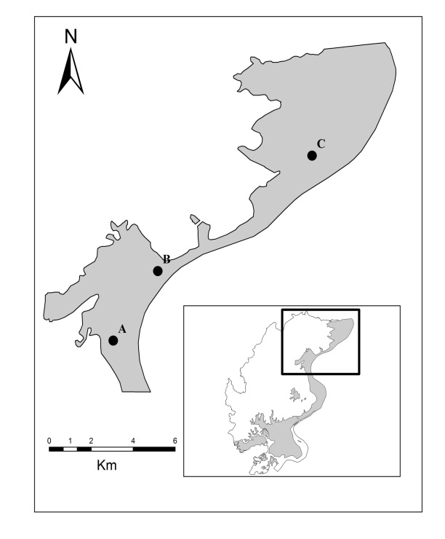
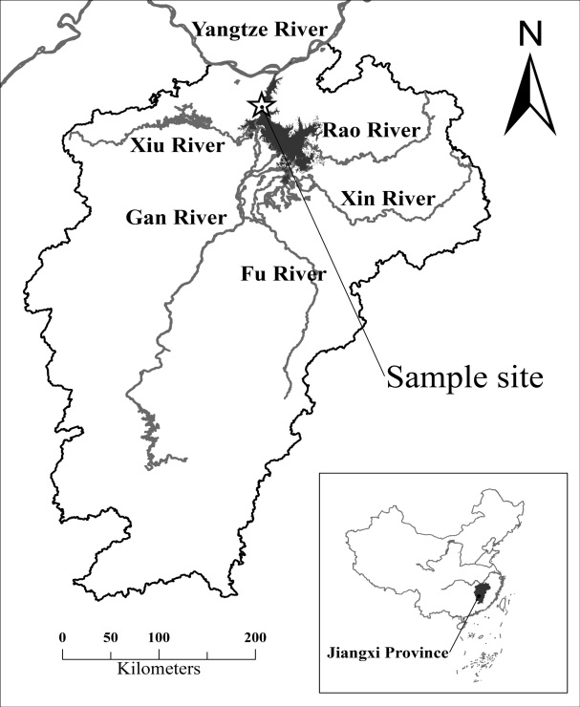
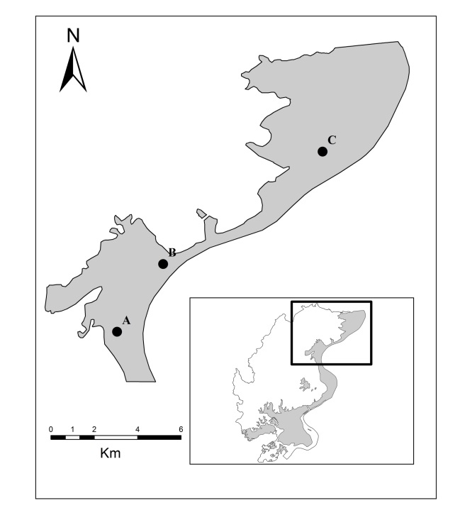
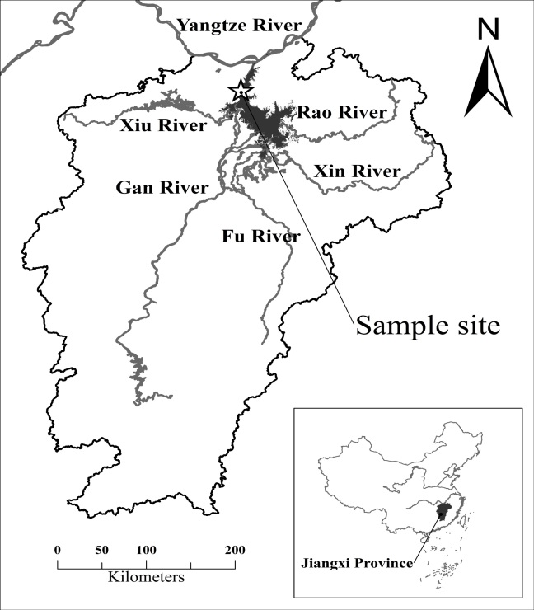

Fig. 2
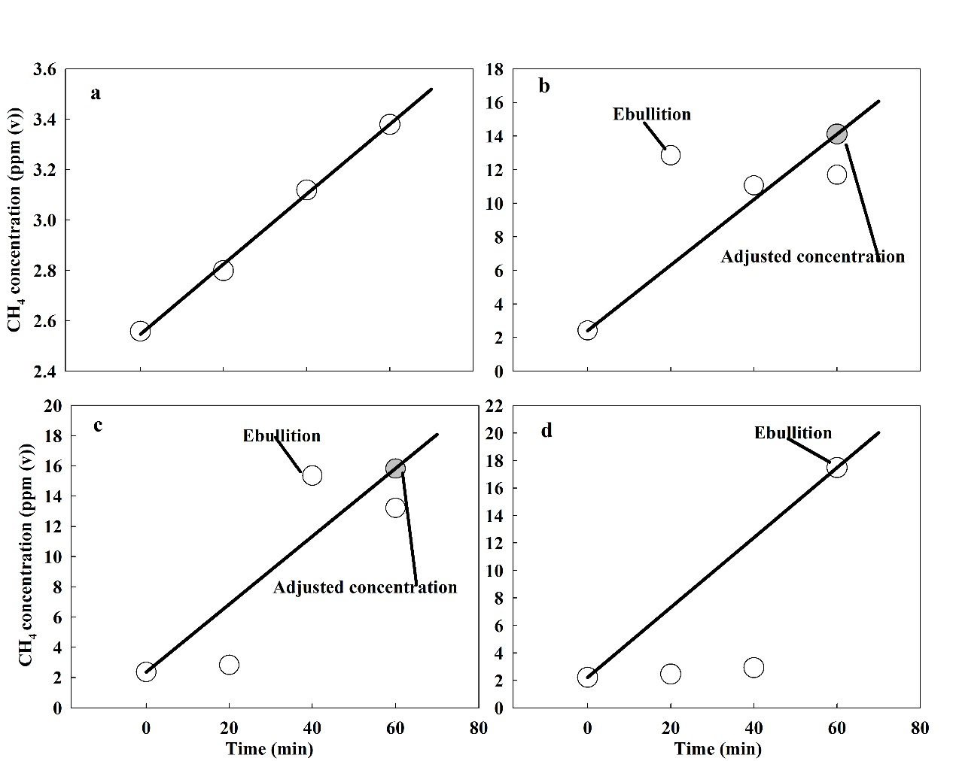

Fig. 3
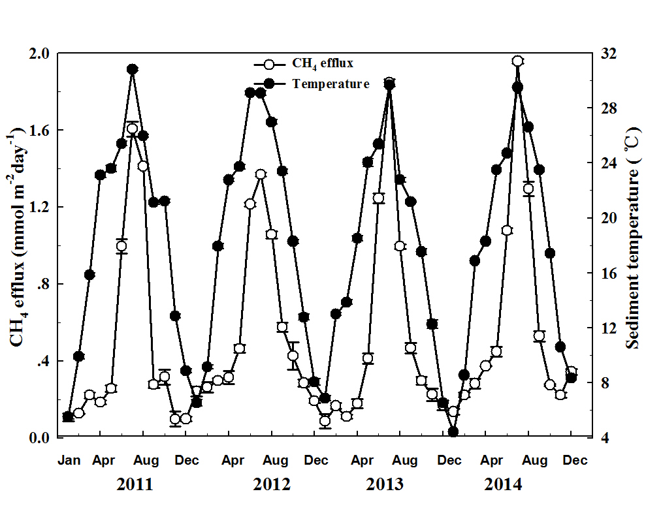

Fig. 4

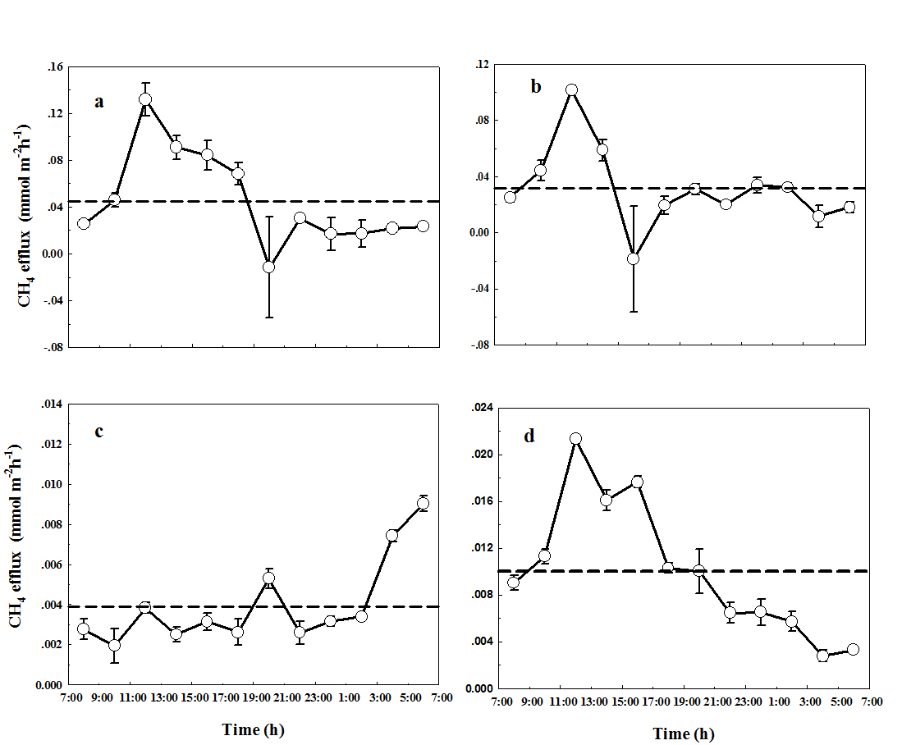

Fig.5
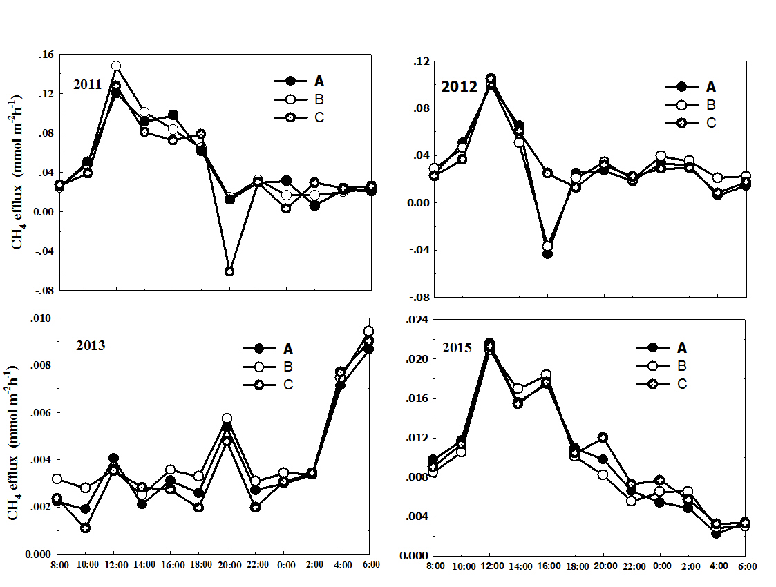
Fig. 6

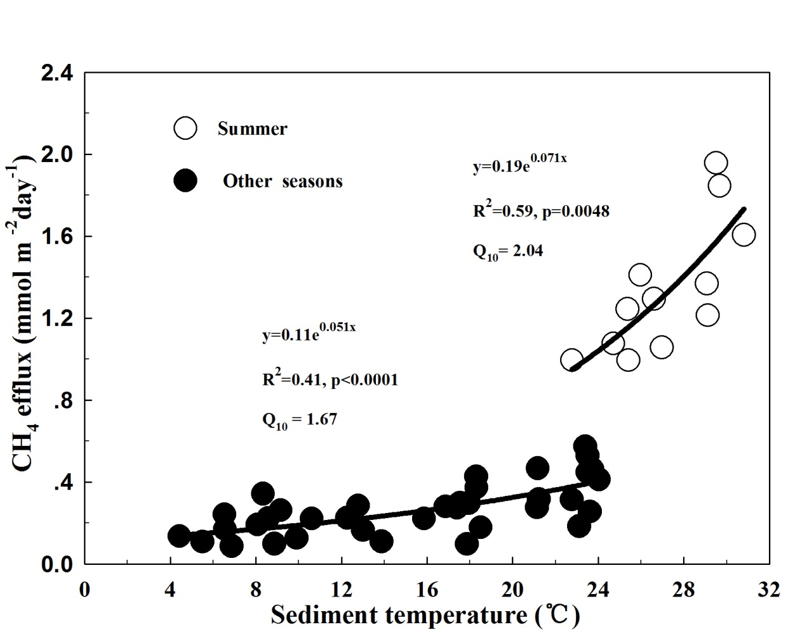

Fig.7

